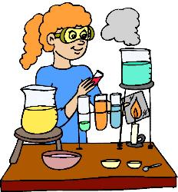
Welcome back! This year we are going to be learning about many exciting things all centered around the science of chemistry and physics, including: properties of matter, physical & chemical changes, the periodic table of elements, motion, forces and many other topics. What you learn this year will appear on the Science MCAS that you will take in May. To help you to do well on this MCAS, we will be doing things like reading, lab activities, projects, group work, etc. In addition, the following resources will help you to study and keep you up to date on what’s going on in class:
http://RMAscience.weebly.com
Follow me on : @MrsJohnsonRMA

Sign up for the Remind101.com text messages
(see my website or the attached colored paper for instructions)
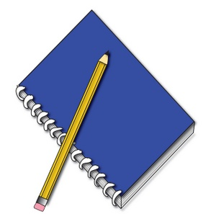
Required materials:
- 3 ring binder (you can share one with another class) OR a folder
just for this class
- Loose-leaf paper OR a spiral-bound notebook
- Pencils or pens (a lot!) and erasers (you should have at least a few
pencils for when we make graphs or take scantron tests)

Suggested materials:
- Dividers (for your binder)
- A homework folder (you could share this with all of your classes)
- Colored pencils to keep at home (if you need to finish something at home that requires it to be colored in)
- Highlighters

*If you do not think you can afford any of the required materials, speak with me and I will try to help you out.

My expectations for you:
- Respect. This means respect your classmates, the classroom, the class materials and myself. If you show respect for others, people will respect you.
- Be prepared for class. This means everyday you will bring a pen or pencil, your binder and any textbook that I give you.
- Give full effort on your work. This includes participating in class discussions, finishing assignments and turning them in.
- Be responsible for your own actions. This includes your behavior, participation and making up missed work. (This will be explained on the next page)
- Be on your best behavior. Failure to act appropriately could result in consequences such as zeros on work, a call home to your parent/guardian, being removed from class by the assistant principal, etc.

Textbooks:
For this class we will be using a variety of textbooks to support your learning. They will be kept in class and left under your desk. If you need to take one home please see me so you can sign one out. I will check with you the next day to make sure you have returned it.

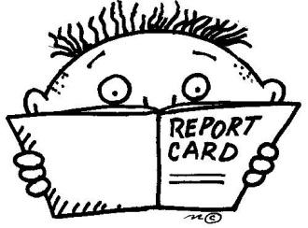
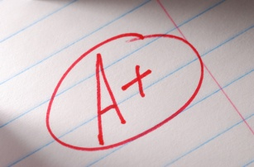
Grading policy:
Tests – 40%
Quizzes – 30%
Labs/other assignments – 20%
Homework and Classwork – 10%
Late homework is NOT accepted. Labs and other assignments
will have 10 points taken off for each day late.

Please note that assignments not completed in class will be required to be finished as homework and due the next day. Homework will occasionally be assigned and is due the next day.

Make up work policy:
If you are absent, on the day that you return you must check the “What Did I Miss?” folder for your class and complete the assignment(s) in the folder within two school days of your return (you must show me the complete assignment). If you missed notes, you must get them from a classmate. If you missed a lab, it is your responsibility to stay after school within one week to make up the lab. If you miss a lab you will get a zero for that assignment, and this could really hurt your grade.

Science Fair:
Completing a Science Fair project is a great way to do an experiment about something that you find interesting (or design a machine/structure that solves a problem that you would like to fix). It is required for ALL students. There will be due dates throughout the year to help to keep you on track for the Science Fair in the spring and will be discussed in more detail starting around October.

Bathroom/Nurse :
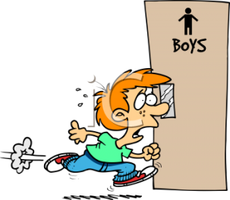
If you have to use the bathroom or need to see the nurse, please raise your hand and ask. Please write a pass with your name, where you are going and the time. I must sign your pass before you leave.

**Please be aware that, unless it is a real emergency, there are some times that I will ask you to stay in the classroom because we are doing something that I do not want you to miss. Also be aware that if I feel as though you are leaving the classroom too much to go to the bathroom, I do not have to let you go (unless the nurse has a note from your parent or doctor saying that you need to use the bathroom or see the nurse frequently).**

Lab Rules:
- Read and follow the procedure before you begin an experiment.
- Be safe! If there is an accident or if something breaks, please notify the teacher immediately.
- Work only with your partner or group.
Partners DO NOT: wander around looking for/giving free answers, visit with other lab groups and/or copy another group’s lab results.
- Complete a lab assessment and pass it in on time.
- Appropriate behavior is a must. Acting inappropriately will result in being removed from your group/partner and coming after school to finish the lab. Serious misconduct will result in a zero in the lab.
- You may only use the equipment/objects for their intended way in the lab. If you do not, see above for consequence.
- You must clean up and return equipment to the proper area at your lab station at the end of the class period. If I have to clean up your lab station then points will be deducted from your lab grade.

Cell Phone Policy:
Cell phones will be allowed for the purpose of writing down when assignments are due, however you must have the “License to Operate Technology” form signed by your parent/guardian. If you are using your phone when you should not be, or using it to send/receive text messages, I will confiscate it and give it to the assistant principal. You will only be given the phone back if your parent/guardian comes in to get your phone.

Academic Dishonesty Policy:
If a student is found guilty of academic dishonesty (cheating), the teacher will collect the assignment, mark a zero for the work, notify the parent/guardian of the event, and refer the student to administration. Academic dishonesty includes things such as copying someone else’s assignment, letting someone else copy your assignment and plagiarism, which is when you pass in work that is not your own (for example, copying and pasting information from the internet and passing it off as your own).

I have read Mrs. Johnson’s science class policies and procedures and I agree to follow them.

Student name (please print): ______________________________________ Class: 8-_____
Student signature: __________________________________________________________
Parent/Guardian Signature: _________________________________________________
Date: __________________________________________________

I have read Mrs. Johnson’s science class policies and procedures and I agree to follow them.

Student name (please print): ______________________________________ Class: 8-_____
Student signature: __________________________________________________________
Parent/Guardian Signature: _________________________________________________
Date: __________________________________________________

